**DBMS ASSIGNMENT 4**

**DATE :- 06/02/2025**

**AIM of the Practical :-**

**To Perform various data manipulation commands, aggregate functions and sorting concept on all created tables.**

1. List total deposit from deposit.



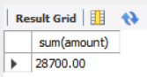

1. List total loan from karolbagh branch



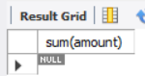

1. Give maximum loan from branch vrce.



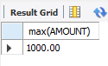

1. Count total number of customers



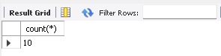

1. Count total number of customer’s cities.



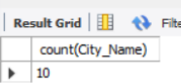

1. Create table supplier from employee with all the columns.



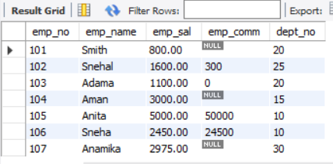

1. Create table sup1 from employee with first two columns.



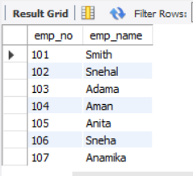

1. Create table sup2 from employee with no data



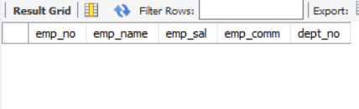

1. Insert the data into sup2 from employee whose second character should be ‘n’ and string should be 5 characters long in employee name field.



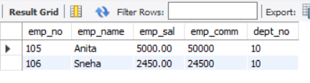

1. Delete all the rows from sup1.



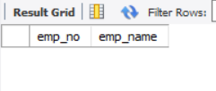

1. Delete the detail of supplier whose sup_no is 103.



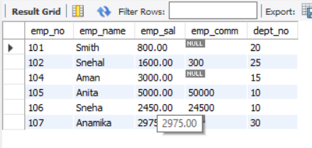

1. Rename the table sup2.



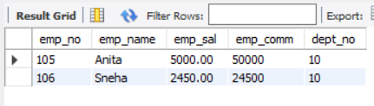

1. Destroy table sup1 with all the data.





1. Update the value dept_no to 10 where second character of emp. name is ‘m’.



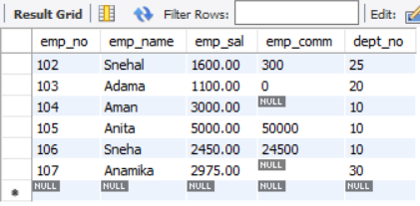

16) Update the value of employee name whose employee number is 103.



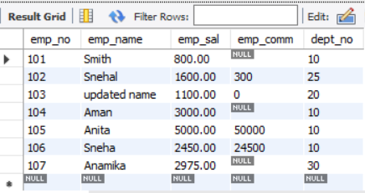

17) Add one column phone to employee with size of column is 10.



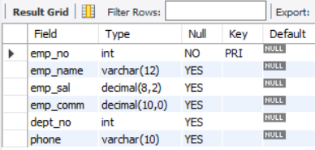

1. Modify the column emp_name to hold maximum of 30 characters.



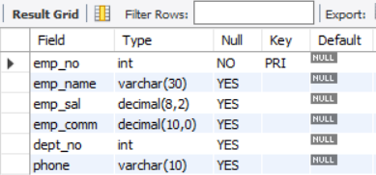

1. Count the total no as well as distinct rows in dept_no column with a condition of salary greater than 1000 of employee.



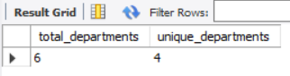

1. Display the detail of all employees in ascending order, descending order of their name and no.

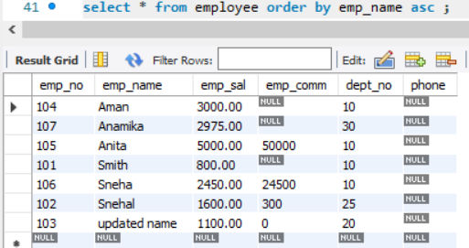

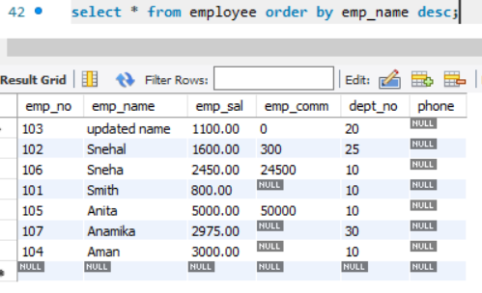

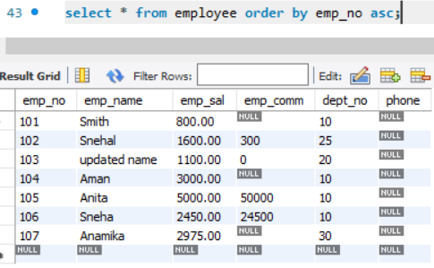

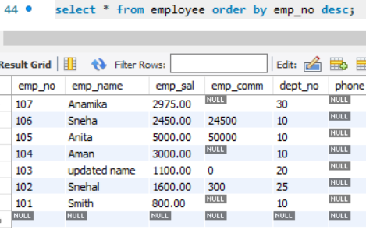

1. Display the dept_no in ascending order and accordingly display emp_comm in descending order.

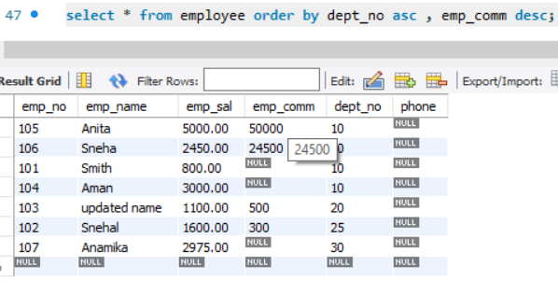

1. Update the value of emp_comm to 500 where dept_no is 20.

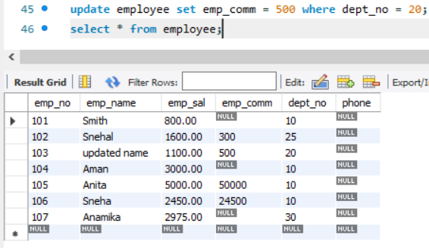

1. Display the emp_comm in ascending order with null value first and accordingly sort employee salary in descending order.

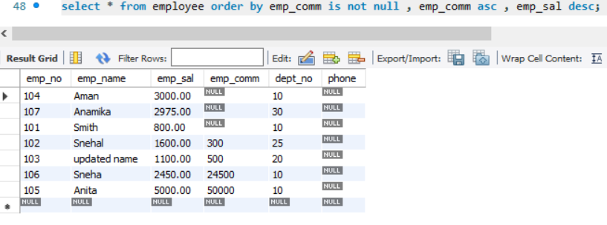

1. Display the emp_comm in ascending order with null value last and accordingly sort emp_no in descending order.

